**Homework:**

**Problem 1:**

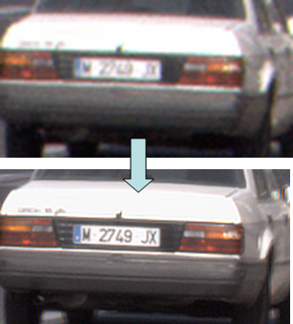**Image denoising:** when we want to reduce noise effect and also preserve features of photo.

**Image restoration:** when our imagedestroyed or some features has been lost (noise, movement) and by some techniques we want to restore that hidden or faded features.

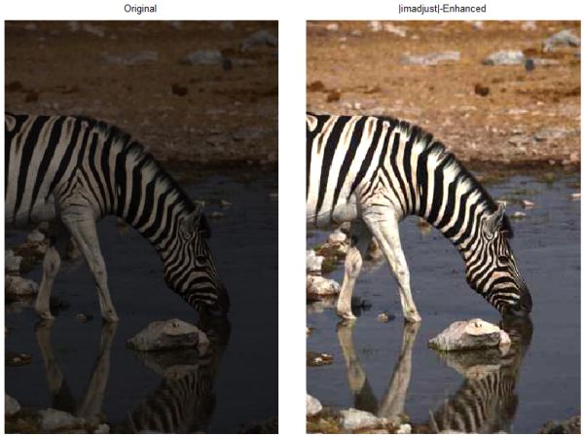

**Image enhancement:** when our image doesn’t have appropriate gray level. The technique we use reduces the lowest grey values to black and the highest to white

**Problem 2:**

Well we cannot say which filter is the best for all kind of noise because every noise has different density and variance. Based on results for question 1 best filter in compassion with other two, we have following result:

1. **Gaussian noise:** best result achieved by Arithmetic mean filter.
2. **Salt & pepper noise:** best result achieved by Arithmetic mean filter. We know that harmonic filter is proper for salt noise but here because image also consist of paper noise, so it fails to act properly.
3. **Rayleigh noise:** best result achieved by Geometric mean filter also Arithmetic mean filter has an acceptable result.

**Problem 3:**

The reason that geometric mean filter is less blurred is that in theses filters we obtain filtered image by smoothing. We know that in arithmetic filter it noise reduction is result as blurring, so blurring is it property.

In this series of pictures we have two kind of mean filters.

So if our pixels in the spatial domain are like this: 6 6 6 6 0 0 6 6 6 6

We will have following results:

* Arithmetic filter ͢ 6 6 6 4 2 2 4 6 6 6
* Geometric filter ͢ 6 6 6 0 0 0 0 6 6 6 the number of zeros has been increased it means that we have thicker black line in comparison to the original noisy image.

So we have good image (features of image does not change, I mean thickness of black lines).

As the Laplacian and mean are linear operations, so order of applying does not affect the result.